Assignment - II

## 1. Check if a number is Positive, Negative, or Zero

IPO:

* Input: A number
* Process: Check if number > 0, < 0 or = 0
* Output: Message indicating if it's positive, negative, or zero

#include <stdio.h>  
  
void main() {  
 int num;  
 printf("Enter a number: ");  
 scanf("%d", &num);  
  
 if(num > 0)  
 printf("Positive\n");  
 else if(num < 0)  
 printf("Negative\n");  
 else  
 printf("Zero\n");  
}

Output:

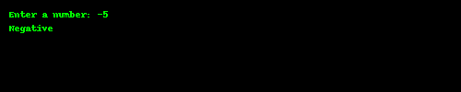

## 2. Largest Among Three Numbers

IPO:

* Input: Three numbers
* Process: Compare using if-else
* Output: Largest number

Code:

#include <stdio.h>  
  
void main() {  
 int a, b, c;  
 printf("Enter three numbers: ");  
 scanf("%d%d%d", &a, &b, &c);  
  
 if(a >= b && a >= c)  
 printf("Largest is %d\n", a);  
 else if(b >= a && b >= c)  
 printf("Largest is %d\n", b);  
 else  
 printf("Largest is %d\n", c);  
}

Output:

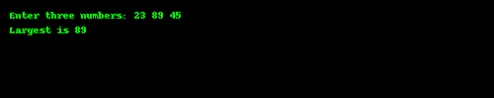

## 3. Leap Year Check

IPO:

* Input: Year
* Process: Check leap year condition
* Output: Leap or not

Code:

#include <stdio.h>  
  
void main() {  
 int year;  
 printf("Enter a year: ");  
 scanf("%d", &year);  
  
 if((year % 4 == 0 && year % 100 != 0) || year % 400 == 0)  
 printf("Leap Year\n");  
 else  
 printf("Not a Leap Year\n");  
}

Output:

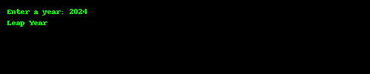

## 4. Vowel or Consonant

IPO:

* Input: A character
* Process: Check if it is a, e, i, o, u
* Output: Vowel or consonant

**Code:**

#include <stdio.h>  
  
void main() {  
 char ch;  
 printf("Enter a character: ");  
 scanf(" %c", &ch);  
  
 if(ch=='a'||ch=='e'||ch=='i'||ch=='o'||ch=='u'||  
 ch=='A'||ch=='E'||ch=='I'||ch=='O'||ch=='U')  
 printf("Vowel\n");  
 else  
 printf("Consonant\n");  
}

Output:

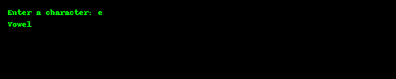

## 5. Grade Based on Marks

**IPO:**

* Input: Marks
* Process: Assign grades by range
* Output: Grade

Code:

#include <stdio.h>  
  
void main() {  
 int marks;  
 printf("Enter marks: ");  
 scanf("%d", &marks);  
  
 if(marks >= 90)  
 printf("Grade A\n");  
 else if(marks >= 80)  
 printf("Grade B\n");  
 else if(marks >= 70)  
 printf("Grade C\n");  
 else if(marks >= 60)  
 printf("Grade D\n");  
 else  
 printf("Fail\n");  
}

Output:

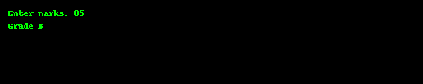

## 6. Divisible by 5 and 11

IPO:

* Input: Number
* Process: Check divisibility by 5 and 11
* Output: Yes or No

Code:

#include <stdio.h>  
  
void main() {  
 int num;  
 printf("Enter a number: ");  
 scanf("%d", &num);  
  
 if(num % 5 == 0 && num % 11 == 0)  
 printf("Divisible by 5 and 11\n");  
 else  
 printf("Not Divisible\n");  
}

Output:

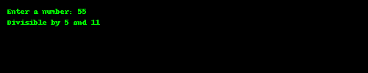

## 7. Absolute Value

IPO:

* Input: Number
* Process: If negative, multiply by -1
* Output: Absolute value

**Code:**

#include <stdio.h>  
  
void main() {  
 int num;  
 printf("Enter a number: ");  
 scanf("%d", &num);  
  
 if(num < 0)  
 num = -num;  
  
 printf("Absolute value: %d\n", num);  
}

Output:

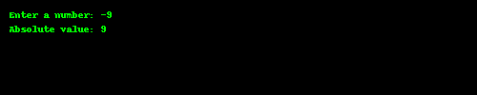

## 8. Menu-Driven Calculator

IPO:

* Input: Two numbers and choice
* Process: Switch based on choice
* Output: Result

Code:

#include <stdio.h>  
  
void main() {  
 int a, b, choice;  
 printf("Enter two numbers: ");  
 scanf("%d%d", &a, &b);  
  
 printf("1. Add\n2. Subtract\n3. Multiply\n4. Divide\n");  
 printf("Enter choice: ");  
 scanf("%d", &choice);  
  
 switch(choice) {  
 case 1: printf("Result = %d\n", a + b); break;  
 case 2: printf("Result = %d\n", a - b); break;  
 case 3: printf("Result = %d\n", a * b); break;  
 case 4:   
 if(b != 0)  
 printf("Result = %.2f\n", (float)a / b);  
 else  
 printf("Cannot divide by zero\n");  
 break;  
 default: printf("Invalid choice\n");  
 }  
}

📷 Sample Output:

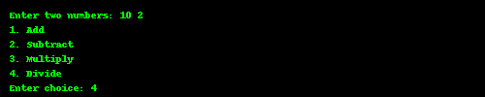

## 9. Roots of Quadratic Equation

IPO:

* Input: a, b, c
* Process: Use formula (-b±sqrt(b²-4ac))/2a
* Output: Roots

Code:

#include <stdio.h>  
#include <math.h>  
  
void main() {  
 float a, b, c, d, root1, root2;  
 printf("Enter coefficients a, b and c: ");  
 scanf("%f%f%f", &a, &b, &c);  
  
 d = b*b - 4*a*c;  
  
 if(d > 0) {  
 root1 = (-b + sqrt(d)) / (2*a);  
 root2 = (-b - sqrt(d)) / (2*a);  
 printf("Real and Distinct Roots: %.2f and %.2f\n", root1, root2);  
 }  
 else if(d == 0) {  
 root1 = -b / (2*a);  
 printf("Real and Equal Roots: %.2f\n", root1);  
 }  
 else {  
 printf("Complex Roots\n");  
 }  
}

Output:

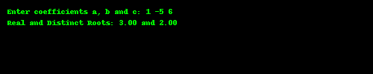

## 10. Number of Digits

## IPO:

* Input: Integer number
* Process: Divide by 10 and count
* Output: Number of digits

Code:

#include <stdio.h>  
  
void main() {  
 int num, count = 0;  
 printf("Enter a number: ");  
 scanf("%d", &num);  
  
 if(num == 0)  
 count = 1;  
 else {  
 while(num != 0) {  
 num /= 10;  
 count++;  
 }  
 }  
  
 printf("Number of digits: %d\n", count);  
}

Output:

